Project Progress

Submission-4

Project Name: **Equation Solver**

Written By: **Alim Ul Karim**(**112 0821 042**) & **Alvee Rahman (**112 0350042)

Contacts: Alim Ul Karim [alim.karim.nsu@gmail.com](mailto:alim.karim.nsu@gmail.com) and +8801673175222

Alvee Rahman [alveeibnerahman@yahoo.com](mailto:alveeibnerahman@yahoo.com) and +8801824513578

On Going Progress:

Alim Ul Karim: I have managed to complete the main function of all, which can solve any between number values from an expression. Now, I have very_number function, which I can use to determine if it is a number or an expression, if not a number then it must be an expression. Unless, it is a valid number my function will call its nested element to do things recursively.

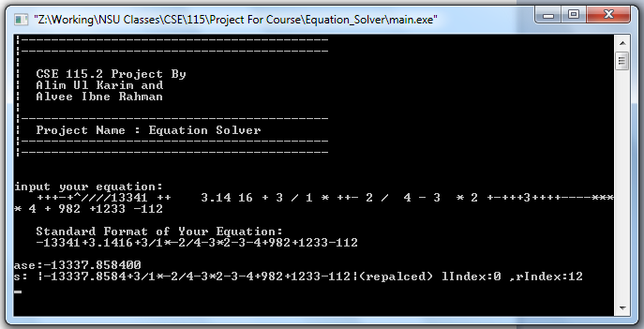

Project is now 80% done. I have tried to implement bigint but there are some issues that I could not solve. In above picture I have solved first ‘+’ expression.

Alvee Rahman : Communication gap.